Alcohol use disorder is a global health issue with dire social and economic costs, understanding the neuronal pathways and its effect on neurotransmitter-signaling systems, and how they are altered, will help to design new gene targeting drugs to suppress alcohol addiction and alleviate withdrawal symptoms.

**Biological question**: Acute alcohol administration increases the firing of VTA dopamine neurons. My aim is to investigate the characterization of D1 dopamine receptor activity during alcohol relapse and to classify unequivocally dopamine activity by correlating cluster of VTA neurons based on their physical location in the nucleus accumbens[1].

**Research model**

* To study the activity across the dopamine system, we will measure dopamine release using the GPCR indicator dLight during alcohol-seeking period.
* Laboratories animals will be Th-Cre rats[2] and will receive the genetically encoded CAG promoter pAAV-CAG-dLight1.1[3] . LEDS will generate two excitation wavelengths at 405 nm (isosbestic control signal) and 465 nm (Ca2+ dependent signal).
* Optical measurements will be measured by femtowatt photoreceivers at various locations of the nucleus accumbens (core, above medial accumbens sheel, lateral accumbens shell).
* Signals will be downsampled and processed:
  + ratio will be calculated where:

, F: Ca2+ dependent signal, : isosbestic signal

* will be low-pass filtered
* within a time-window around events will be compiled and be averaged
* 95% CI will be calculated for each event recording and used to filter events[4]
* The rats will be placed in a chamber with a pump located on the wall of the chambers. Activating the dispenser extinguishes a blue light, and triggers a syringe which delivers alcohol. The rats will be trained and tested following a context induced reinstatement procedure[5]: to use context as a factor, two contexts with different olfactory and tactile and visual properties will be created.
* Rats will be initially trained in the context where an activated pump by the rat, stops the light and dispenses alcohol. Then the rats are trained in an alcohol-missing context where the same pump when activated stops the light but doesn’t deliver alcohol. The training phase is followed by a testing phase, the rats are self-controlling the nose: they are first in the alcohol-missing context then they are placed in the alcohol-context. Signals will be recorded at each stage of this procedure.
* We will use (RSA), for data analysis to compare similarities between brain activity and the different stages of the measurements: start of test alcohol-missing phase, end of test alcohol-missing phase, start of test alcohol-context phase, end of test alcohol-context phase. A first order representational dissimilarity matrix (RDMs)[6] will be constructed. The pairwise correlation distances will indicate to which degree each pair of activity patterns are similar or dissimilar across experiment phases. A second-order Brain RDM across the first-order RDM will allow to factor out the experiment stages and only report similarity/dissimilarity between brain regions (see example in references).
* Compared to small molecule probes, genetically encoded indicators G-protein coupled receptors (GPCR), are small, easy to express in an AAV, can target specific cells, and can be expressed over long periods of time. In addition, dLight indicators have reported faster kinetics than many similar probes.
* In this model we want to detect in the least evasive manner dopamine activity and to our knowledge there is not an opsin indicator to DA, mature enough available (when using opsin indicators, we will need to consider off-target neuron selection, unwanted physiological changes, or collateral activation of other brain regions).
* We may want to confirm the dLight probe measurements with an indirect measure of DA release by measuring presynaptic calcium release in VTA neurons using the genetically encoded fluorescent probe GCaMP6f that shows high sensitivity to Ca2+ (if time of the overall experiment permits, we will calibrate GCaMP3, GCaMP3fast and other variants in the same family of probes to increase the sensitivity to calcium release).
* We may also use the metric *d’* from detection theory which takes into account several factors which influence event detection and therefore is a better metric than fractional fluorescence change ().

**References**:

1. Cody A. Siciliano and Kay.M.Tye, Leveraging calcium imaging to illuminate circuit dysfunction in addiction, Elsevier, Alcohol 74 (2019) 47-63
2. Marue A.Labouesse, Reot B.Cola, Tommaso Patriarchi , MDPI, GPCR-Based Dopamine Sensors—A Detailed Guide to Inform Sensor Choice for In Vivo Imaging
3. Sachin Moonat et al., Neuroscience of Alcoholism: Molecular and Cellular Mechanisms, 2010 January ; 67(1): 73–88. doi:10.1007/s00018-009-0135-y
4. Kristin M Scaple and Emily Petrucelli, Neuroscience Insights, Volume 16, March 2021, doi: 10.1177/26331055211007441, Receptors and Channels Associated with Alcohol Use: Contributions from *Drosophila*
5. Grace O.Mizuno et al., Department of Biochemistry and Molecular Medicine, School of Medicine, University of California, Davis, real time monitoring of neuromodulators in behaving animals genetically encoded indicators
6. Example of dissimilarity matrix

From <https://journals.plos.org/ploscompbiol/article?id=10.1371/journal.pcbi.1003553>

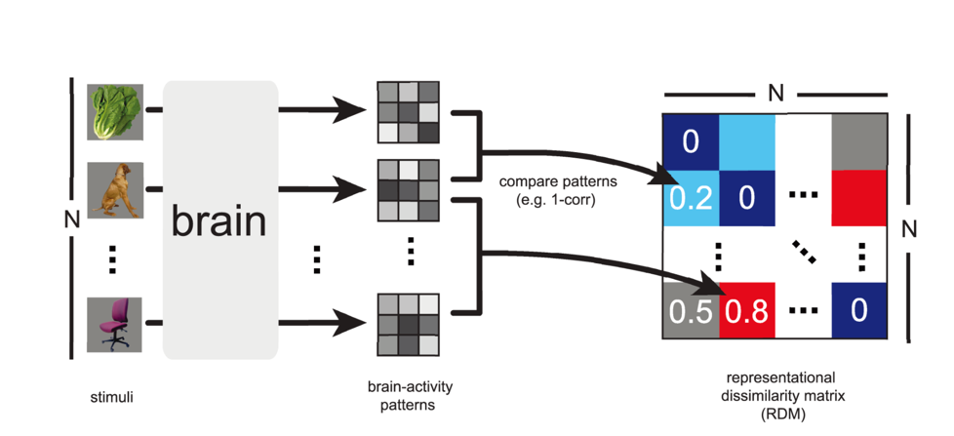

“During the experiment, each subject's brain activity is measured while the subject is exposed to N experimental conditions, such as the presentation of sensory stimuli. For each brain region of interest, an activity pattern is estimated for each experimental condition. For each pair of activity patterns, a dissimilarity is computed and entered into a matrix of representational dissimilarities. When a single set of response-pattern estimates is used, the RDM is symmetric about a diagonal of zeros. The dissimilarities between the activity patterns can be thought of as distances between points in the multivariate response space. An RDM describes the geometry of the representation and serves as a signature that can be compared between brains and models, between different brain regions, and between individuals and species.”

1. Relapse being defined as humans going back to drinking after stopping, and similar behavior has been observed in rodents, humans re-exposed to alcohol return to pre-abstinence levels of drinking
2. TH-Cre rat is the generally the animal used in research requiring tissue specific expression
3. From addgene
4. Compute CI for each recording and keep events which are significant and not too similar: <https://statisticsbyjim.com/hypothesis-testing/confidence-intervals-compare-means/>
5. <https://pubmed.ncbi.nlm.nih.gov/27612655/>
6. <https://www.frontiersin.org/articles/10.3389/neuro.06.004.2008/full>